CO03 Logbook: Strange mesons from proton-antiproton collisions at the CDF experiment
  - Berhan Merha-Tsidk – kebl8364 – 21/02/2026-13/04/2026

The example:
I first downloaded the cdf.dat (which holds all of the raw data), CdfDataFile.m (presents the data), CdfEvent.m, CdfTrack.m, Loop.m, Histogram.m and Analysis.m files onto my computer from the lab script. To see how the data would be presented I ran:
help CdfDataFile

and got:

CdfDataFile wraps CDF track data file.
This class reads a CDF track data file sequentially.
The format: each event consists of the following:
line 1: runNumber eventNumber vertex-x vertex-y numTracks
runNumber = CDF run number
eventNumber = CDF event number within run
vertex-x, vertex-y = transverse location (xy) of primary interaction point
numTracks = number of reconstructed tracks
lines 2 to numTracks-2: cotTheta curvature d0 phi0 z0
cotTheta = polar angle of track at closest approach to (0,0)
curvature = track curvature (actually 0.5*curvature) in xy plane
d0 = impact parameter with respect to origin at point of closest approach
phi0 = azimuthal angle at point of closest approach
z0 = position along beamline at point of closest approach

which explained how the data was structured in the cdf.dat file.

After learning how each class of object worked, along with its properties and methods, I used the classes to read the first few lines of the data file:

f = CdfDataFile('cdf.dat');
e = f.next();
for i=1:5
disp(e.tracks(i))
end

and I got:
CdfTrack with properties:

cotTheta: -0.4440
curvature: -2.6223e-04
d0: 0.2129
phi0: 1.2150
z0: 110.5150

CdfTrack with properties:

cotTheta: -0.5247
curvature: 7.2349e-04
d0: -0.4320
phi0: 3.4043
z0: 109.9520

CdfTrack with properties:

cotTheta: -0.7597
curvature: -7.4012e-04
d0: -0.3554
phi0: 3.2873
z0: 110.7910

CdfTrack with properties:

cotTheta: 0.0611
curvature: -0.0010
d0: -0.2481
phi0: 2.5363
z0: 110.0600

CdfTrack with properties:

cotTheta: -0.7919
curvature: -0.0011
d0: -0.4100
phi0: 3.2724
z0: 110.8190

This matched the data presented in the first few lines of the file (ignoring the first line), correct to some rounding (from ‘next’ method):

-0.443964 -0.000262233 0.212924 1.215 110.515
-0.524714 0.000723487 -0.432012 3.40432 109.952
-0.759724 -0.000740123 -0.355403 3.28729 110.791
0.0611407 -0.00101644 -0.248064 2.53631 110.06
-0.791874 -0.00114489 -0.410003 3.2724 110.819
-0.161792 0.00124501 0.450138 1.06786 110.526

Building your own class:
Using MATLAB’s utility to create a class template I made the class ‘Helix’ with the properties and constructor given in the lab script. I also made two other methods to find the centre and radius of curvature of the helix in the x-y plane:
% finds radius of curvature
function radius = radius(t)
h = t.trk.curvature;
radius = 1/(2*h);
end

% finds centre of curvature in x-y plane
function centre = centre(t)
r = radius(t);
d0 = t.trk.d0;
phi = t.trk.phi0;
wc = (r+d0)*exp(1i*(phi+pi/2)); % centre encoded as complex exponential
centre(1,1) = real(wc); % real part is the x coord
centre(1,2) = imag(wc); % imag part is the y coord
end

I then tested my code with parameters $h=0.005$cm⁻¹, $d_{0}=1$cm and $ϕ_{0}=-\frac{π}{6}$. At first, I made the mistake of testing this by making a 1x5 array input for the object ‘tr’ of class ‘CdfTrack’, but I corrected this to make a 5x1 array which gave the right results. I also used 1i instead of i for the imaginary unit to avoid confusion with other variables. My code when testing was as follows:
a=[0;
0.0005;
1;
-pi/6;
0];
tr = CdfTrack(a);
h = Helix(tr);
c = h.centre
r = h.radius

which gave me this result:
c =

500.5000 866.8914

r =

1000

I then added the points() method to plot the track that the particle takes. The code was written as follows:
% finds points on the particles track over time
function p = points(tr,t) % what's normally called t is now tr since t represents time
r = radius(tr);
d0 = tr.trk.d0;
phi0 = tr.trk.phi0;
z0 = tr.trk.z0;
cotTheta = tr.trk.cotTheta;
q = 1; % particle has a positive charge +1
wc = (r+d0)*exp(1i*(phi0+pi/2));
w = wc - 1i*r*exp(1i*(phi0+q*t)); % position in x-y plane (complex)
p(1,:) = real(w);
p(2,:) = imag(w);
p(3,:) = z0 + r*t*cotTheta;
end

where I have assumed a positively charged particle ($q=+1$). To test this I plugged in values from the lab report:
t = CdfTrack([ 0.1; 0.05; 1.0; 0.1; 2.0 ]);
h = Helix(t);
v = h.points(0:pi/100:6*pi);
plot3(v(3,:), v(1,:), v(2,:));

which plotted the following graph:
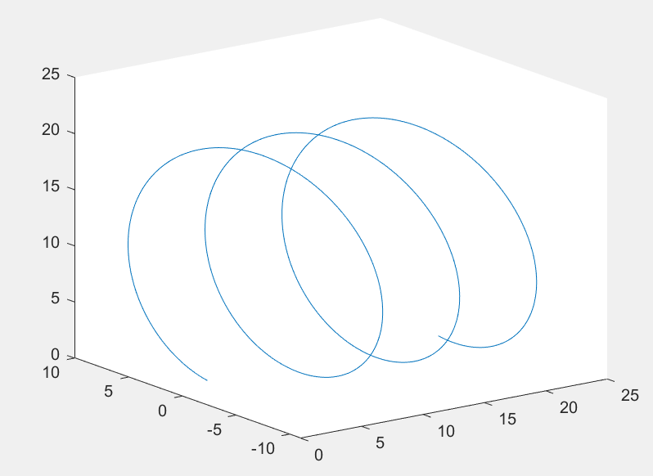
I also plotted a second graph showing the path in the x-y plane only:
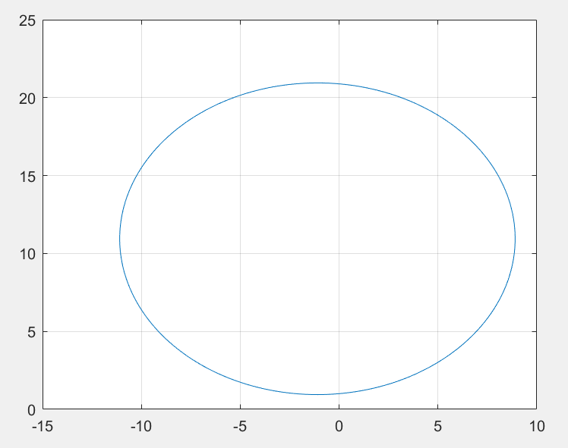
$h=0.05$cm⁻¹
$d_{0}=1$cm
I plotted variations of this graph for different signs of $d_{0}$ and $h$:
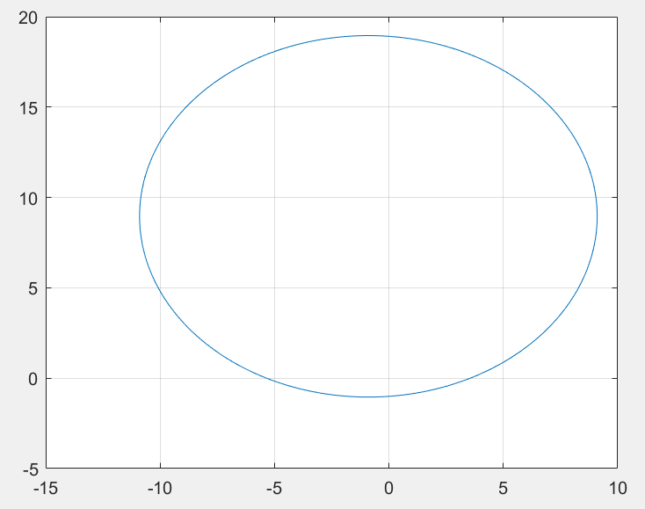
$h=0.05$cm⁻¹
$d_{0}=-1$cm
$h=-0.05$cm⁻¹
$d_{0}=1$cm
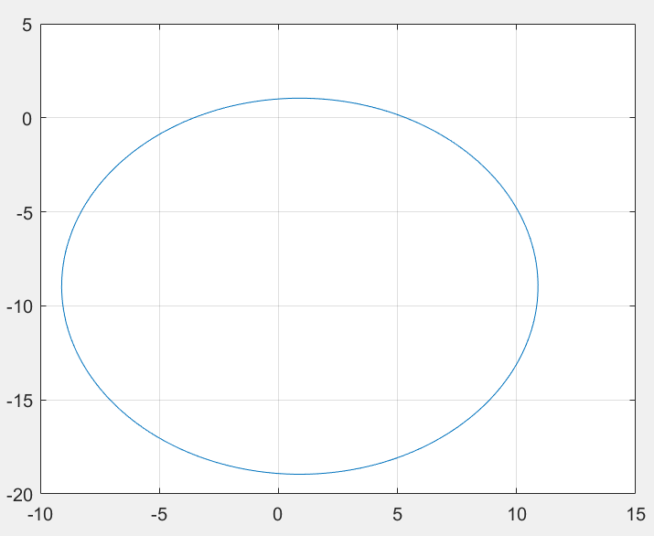
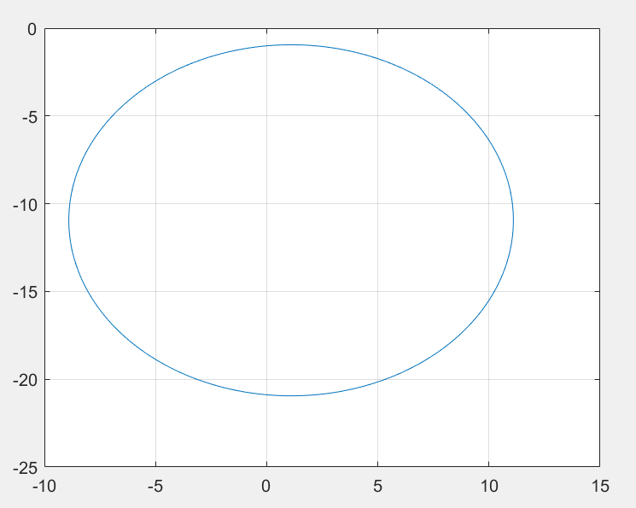
$h=-0.05$cm⁻¹
$d_{0}=-1$cm
As you can see, the centre changes position depending on the signs of $h$ and $d_{0}$, but the radius stays the same.
I then used the lab script code (and tweaked it to match mine) to superpose the tracks of multiple particles found from the cdf.dat file:
f = CdfDataFile('cdf.dat');
ev = f.next();
tt = 0:pi/100:pi/4; % 0 to 90 degrees
hold off; % start a new plot
for index = 1:numel(ev.tracks)
v = Helix(ev.tracks(index)).points(tt);
plot3(v(3,:), v(1,:), v(2,:));
if index == 1
hold on; % superimpose subsequent tracks
axis([-100 100 -100 100 -100 100]); % tracking volume radius ~1m
xlabel('z [cm]'); % beamline
ylabel('x [cm]');
zlabel('y [cm]');
end
end

which gave me this plot:
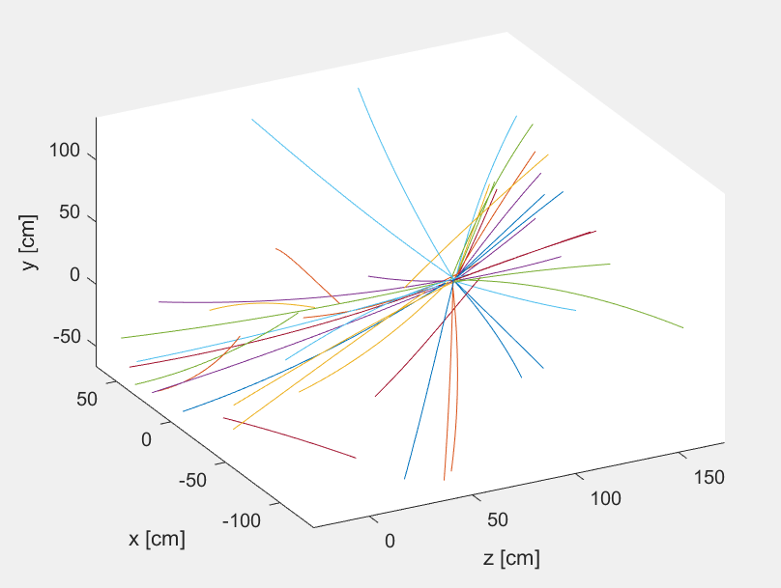
Beams converge around (0,0,100), which matches with the observed z0 values in the data.
Replacing the plot3() line with the plot() line and renaming the axes correctly gave me the plot in the transverse direction (along the beamline):
plot(v(1,:), v(2,:));
if index == 1
hold on; % superimpose subsequent tracks
axis([-100 100 -100 100 -100 100]); % tracking volume radius ~1m
xlabel('x [cm]');
ylabel('y [cm]');

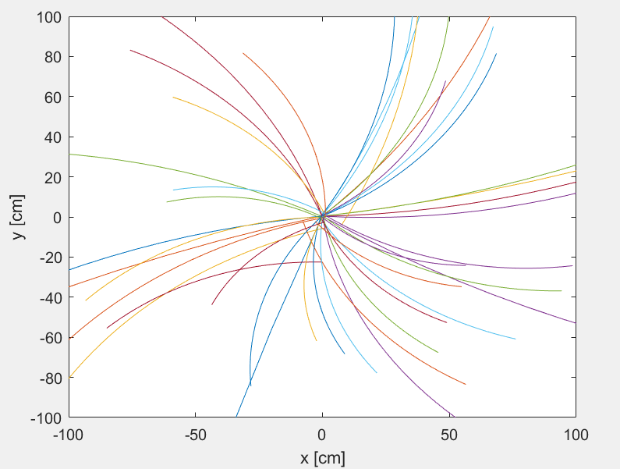
I did the optional challenge to find how tracks with a certain minimum transverse momentum and impact parameter looked on the graph by creating a new class ‘EventDisplay’ which had a few of the same methods as CdfDataFile (isOpen(), close(), rewind(), next()) but also had a method to find the tracks with a specified minimum transverse momentum (found with equation $p_{T}=\frac{k}{h}$, where $k$ is a constant) and minimum impact parameter $d_{0}$. Using this I made methods to either plot only tracks that satisfied these parameters or highlight them by plotting them in a different colour.
The class had a protected property, that being the data it was using to plot these tracks, but also had two public properties so that you could set the desired minimum values to whatever you want in the code.
My code is as follows:
classdef EventDisplay < handle
% EventDisplay lets you choose which tracks to plot.
% Depending on your choice of minimum transverse momentum (MinTM) and minimum
% impact parameter (MinIP) you can choose to either only plot tracks
% that satisfy these restrictions (MinPoints) or emphasise these by plotting in a
% different colour (MinColour).

properties(Access=protected)
dat % cdf data file
end
properties(Access=public)
MinTM % minimum transverse momentum
MinIP % minimum impact parameter
end

methods

% constructor
function obj = EventDisplay(d)
obj.dat = d;
obj.MinTM = 0;
obj.MinIP = 0;
end

% return true if file is open (and valid)
function result = isOpen(obj)
d = obj.dat; % this and the next couple of methods are just stolen from CdfDataFile
result = d.isOpen;
end

% close file
function close(obj)
d = obj.dat;
d.close;
end

% start reading again from the beginning
function rewind(obj)
d = obj.dat;
d.rewind;
end

% get next event
function event = next(obj)
d = obj.dat;
event = d.next;
end

% extracts a modified CdfTrack with transverse momentum higher than
% or equal to MinTM
function mtm = MinTransMom(obj)
obj.rewind % doing the next() method multiple times screws up the object so best to rewind (reset) it every time before you do it
ev = obj.next();
tr = ev.tracks(); % extracting the array with all the track parameters
k = 0.002116; % unit conversion thing from cm^-1 to GeV/c
h=[]; % initialising with an empty array
for i = 1:numel(tr)
h(i) = tr(i).curvature; % extracting an array with only curvature
end
tm = k./h; % equation for transverse momentum
j=1;
mtm = CdfTrack(zeros(5, 1));
for i = 1:numel(tm)
if tm(i) >= obj.MinTM % only values larger than MinTM allowed
mtm(j) = tr(i);
j = j+1; % so that there isn't random space when the inequality isn't satisfied
end
if exist("mtm") == 0 % if no tracks satisfy the requirement...
mtm = []; % ...we need to make sure mtm still exists to plot
end
end

end

% extracts a modified CdfTrack with impact parameter higher than or
% equal to MinIP
function mip = MinImpPar(obj) % same code as before but for the impact parameter instead
obj.rewind
ev = obj.next();
tr = ev.tracks();
d0=[];
for i = 1:numel(tr)
d0(i) = tr(i).d0;
end
j=1;
mip = CdfTrack(zeros(5, 1));
for i = 1:numel(d0)
if d0(i) >= obj.MinIP
mip(1,j) = tr(i);
j = j+1;
end
end
if exist("mip") == 0
mip = [];
end
end

% plots tracks larger than MinTM
function MinPointsTM(obj)
tt = 0:pi/100:pi/4;
tr = obj.MinTransMom();
hold off;
for i = 1:numel(tr)
v = Helix(tr(i)).points(tt);
figure(1) % figures must be numbered so the program doesnt get confused
plot3(v(3,:), v(1,:), v(2,:), "b");
if i == 1
hold on
axis([0 200 -100 100 -100 100]) % to make it centred about (0,0,100) in the written coords (not MATLAB coords!!)
xlabel('z [cm]')
ylabel('x [cm]')
zlabel('y [cm]')
end
end
hold off;
for i = 1:numel(tr)
v = Helix(tr(i)).points(tt);
figure(2)
plot(v(1,:), v(2,:), "b");
if i == 1
hold on
axis([-100 100 -100 100])
xlabel('x [cm]')
ylabel('y [cm]')
end
end
end

% plots tracks larger than MinIP
function MinPointsIP(obj)
tt = 0:pi/100:pi/4;
tr = obj.MinImpPar();
hold off;
for i = 1:numel(tr)
v = Helix(tr(i)).points(tt);
figure(3) % figures are numbered from 3 instead of 1 in case you want to run MinPointsTM at the same time
plot3(v(3,:), v(1,:), v(2,:), "b");
if i == 1
hold on
axis([0 200 -100 100 -100 100])
xlabel('z [cm]')
ylabel('x [cm]')
zlabel('y [cm]')
end
end
hold off;
for i = 1:numel(tr)
v = Helix(tr(i)).points(tt);
figure(4)
plot(v(1,:), v(2,:), "b");
if i == 1
hold on
axis([-100 100 -100 100])
xlabel('x [cm]')
ylabel('y [cm]')
end
end
end

% plots tracks larger than MinTM in red
function MinColourTM(obj)
tt = 0:pi/100:pi/4;
tr1 = obj.MinTransMom(); % all the tracks satisfying the requirement
obj.rewind
ev2 = obj.next();
obj.rewind
tr2 = ev2.tracks(); % all of the tracks
hold off;
for i = 1:numel(tr2)
v = Helix(tr2(i)).points(tt);
figure(1)
plot3(v(3,:), v(1,:), v(2,:), "b");
if i == 1
hold on
axis([0 200 -100 100 -100 100])
xlabel('z [cm]')
ylabel('x [cm]')
zlabel('y [cm]')
end
end
for i = 1:numel(tr1)
w = Helix(tr1(i)).points(tt);
r(i) = plot3(w(3,:), w(1,:), w(2,:), "r"); % collecting all red tracks
end
uistack(r,"top") % putting the red tracks over the blue tracks
hold off;
for i = 1:numel(tr2)
x = Helix(tr2(i)).points(tt);
figure(2)
plot(x(1,:), x(2,:), "b");
if i == 1
hold on
axis([-100 100 -100 100])
xlabel('x [cm]')
ylabel('y [cm]')
end
end
for i = 1:numel(tr1)
y = Helix(tr1(i)).points(tt);
r(i) = plot(y(1,:), y(2,:), "r");
end
uistack(r,'top')
end

% plots tracks larger than MinIP in red
function MinColourIP(obj)
tt = 0:pi/100:pi/4;
obj.rewind
ev2 = obj.next();
obj.rewind
tr2 = ev2.tracks();
tr1 = obj.MinImpPar();
hold off;
for i = 1:numel(tr1)
v = Helix(tr1(i)).points(tt);
figure(3)
r(i) = plot3(v(3,:), v(1,:), v(2,:), "r");
if i == 1
hold on
axis([0 200 -100 100 -100 100])
xlabel('z [cm]')
ylabel('x [cm]')
zlabel('y [cm]')
end
end
for i = 1:numel(tr2)
w = Helix(tr2(i)).points(tt);
plot3(w(3,:), w(1,:), w(2,:), "b");
end
uistack(r,'top')
hold off;
for i = 1:numel(tr1)
x = Helix(tr1(i)).points(tt);
figure(4)
r(i) = plot(x(1,:), x(2,:), "r");
if i == 1
hold on
axis([-100 100 -100 100])
xlabel('x [cm]')
ylabel('y [cm]')
end
end
for i = 1:numel(tr2)
y = Helix(tr2(i)).points(tt);
plot(y(1,:), y(2,:), "b");
end
uistack(r,'top')
end

end % methods
end % classdef

Using this I plotted 8 different graphs to showcase the effectiveness of this new class:
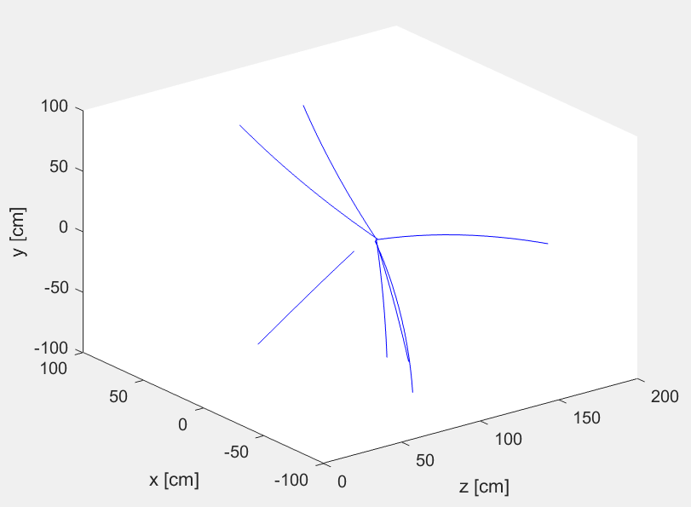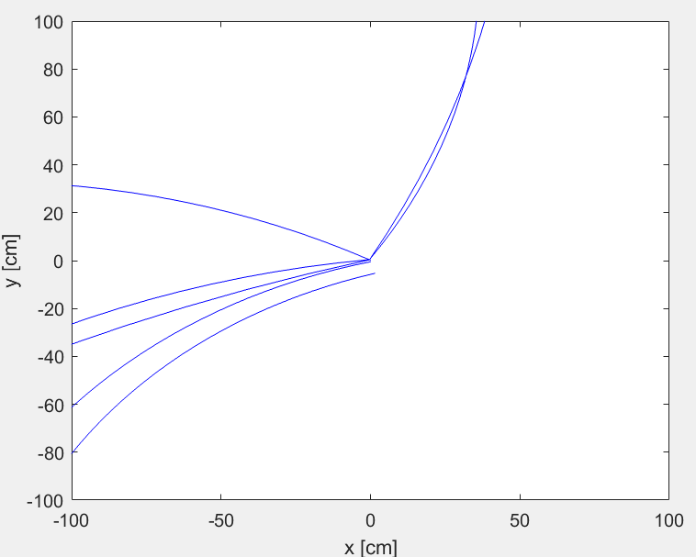
f = CdfDataFile('cdf.dat');
ed = EventDisplay(f);
ed.MinTM = 0.75;
ed.MinPointsTM
all tracks with $p_{T}≥0.75$GeV/c plotted in 3D and in 2D along the beamline.

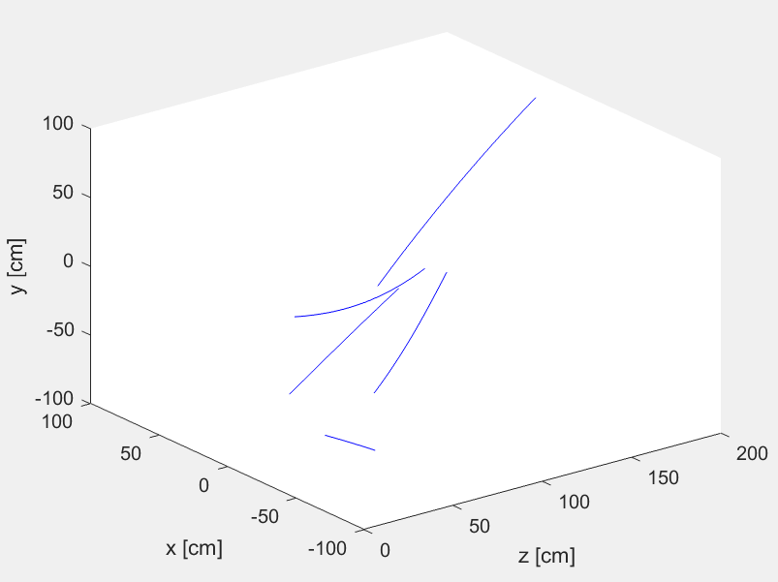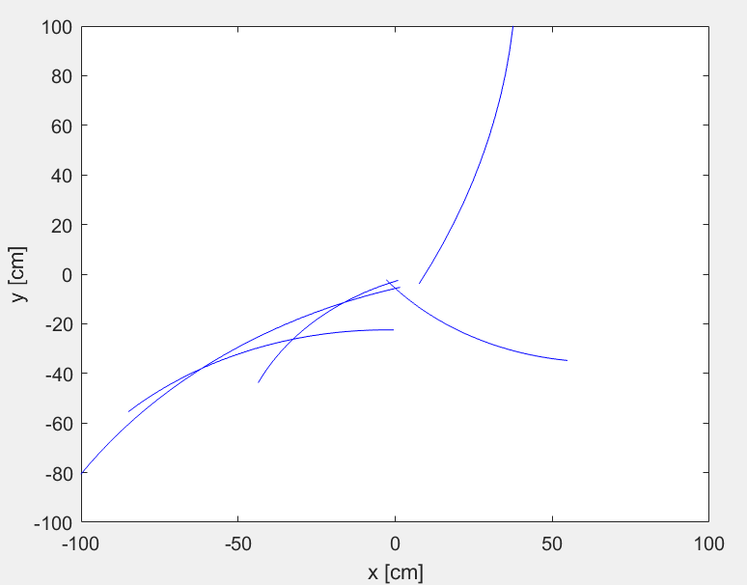
f = CdfDataFile('cdf.dat');
ed = EventDisplay(f);
ed.MinIP = 2;
ed.MinPointsIP
all tracks with $d_{0}≥2$cm plotted in 3D and in 2D along the beamline.

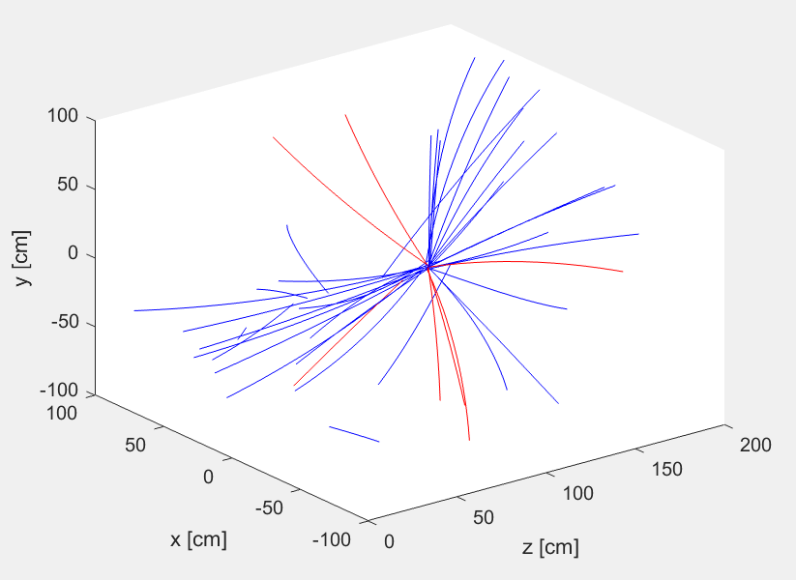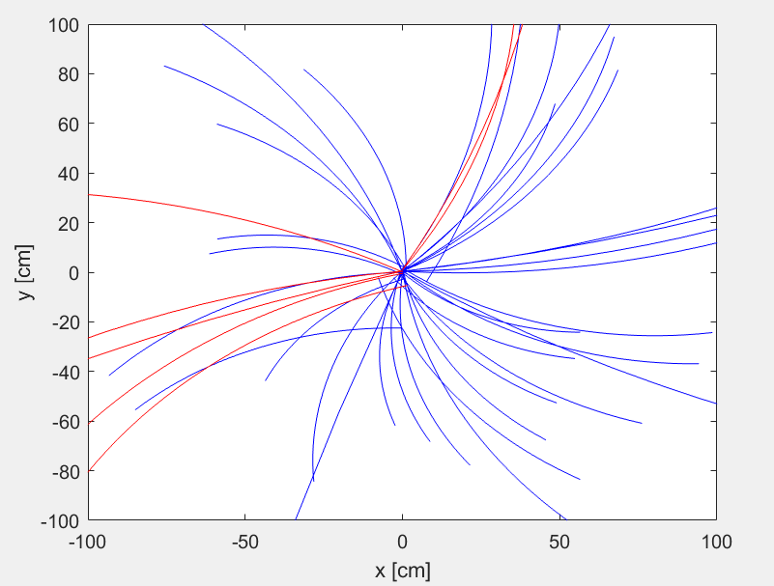
f = CdfDataFile('cdf.dat');
ed = EventDisplay(f);
ed.MinTM = 0.75;
ed.MinColourTM
all tracks plotted blue; tracks with $p_{T}≥0.75$Gev/c plotted red in 3D and in 2D along the beamline.

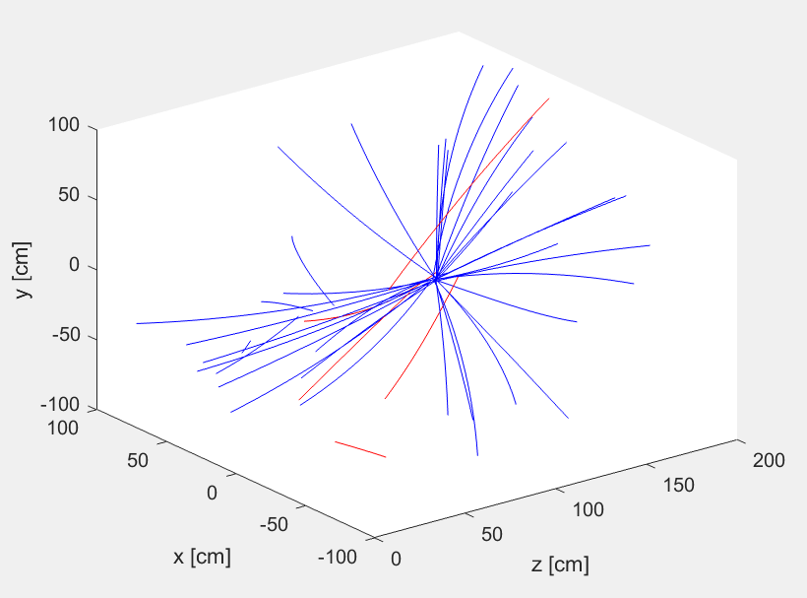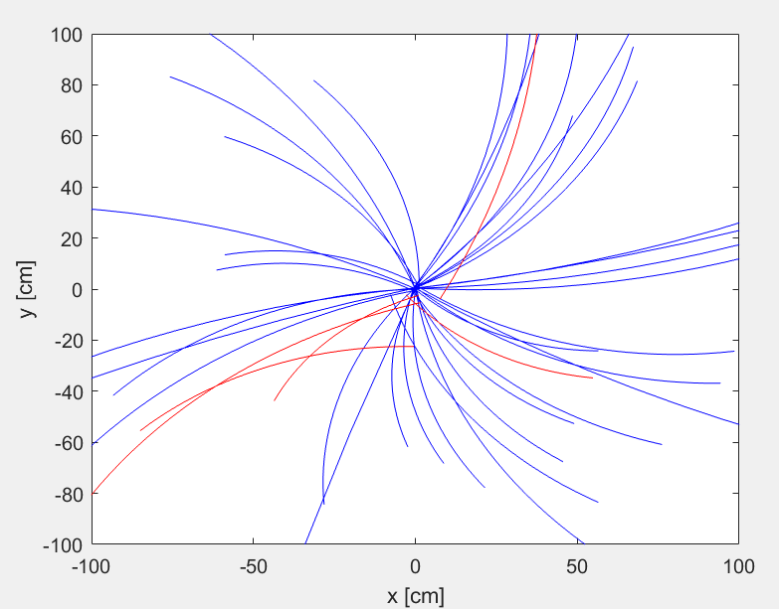
f = CdfDataFile('cdf.dat');
ed = EventDisplay(f);
ed.MinIP = 2;
ed.MinColourIP
all tracks plotted in blue; tracks with $d_{0}≥2$cm plotted red in 3D and in 2D along the beamline.

I tried plotting in different thicknesses (using ‘linewidth’ in plot()) to further accentuate the important tracks, but the appearance looked ugly so I scrapped it.
I later changed the class so that one of the properties it would have is the CdfEvent its on, so less methods would have to be executed within each other.

Reconstructing “strange” particles:
To find the z position of the helices at the (x, y) intersection point I solved the equations given in the lab script for the points() method for t and substituted the value for t I found for each helix:
$t=\frac{\sin^{-1}\left(\frac{w_{±x}-w_{cx}}{r}\right)-ϕ_{0}}{q}$.
Assuming q=+1 I formed my array as shown below (indented):
w = zeros([4,2]); % initialising
w(1,1) = c1(1) + norm(r1) * cos(delta + alpha);
w(1,2) = c1(1) + norm(r1) * cos(delta - alpha);
w(2,1) = c1(2) + norm(r1) * sin(delta + alpha);
w(2,2) = c1(2) + norm(r1) * sin(delta - alpha);
t1p = asin( (w(1,1) - c1(1)) / r1 ) - tr.trk.phi0; % solved eqs for points()
t2p = asin( (w(1,1) - c2(1)) / r2 ) - h.trk.phi0;
t1m = asin( (w(1,2) - c1(1)) / r1 ) - tr.trk.phi0;
t2m = asin( (w(1,2) - c2(1)) / r2 ) - h.trk.phi0;
v1p = tr.points(t1p); % contains z position at point of intersection in (x, y)
v2p = h.points(t2p);
v1m = tr.points(t1m);
v2m = h.points(t2m);
w(3,1) = (v1p(3) + v2p(3))/2; % average z position
w(3,2) = (v1m(3) + v2m(3))/2;
w(4,1) = v1p(3) - v2p(3); % difference in z positions
w(4,2) = v1m(3) - v2m(3);

which gave me a result when I tested it with the lab script code:
t(1) = CdfTrack([ 0.1; 0.0053; 0.01; 0.1; 2.0 ]);
t(2) = CdfTrack([ 0.2; -0.0020; -0.04; 0.2; 2.5 ]);
h = Helix(t);
v = h(1).intersect(h(2))

v =

12.9804 0.5163
2.2365 0.0633
1.5919 2.2241
3.4526 -0.3443

The second column matched with the graph I plotted to check the intersection:
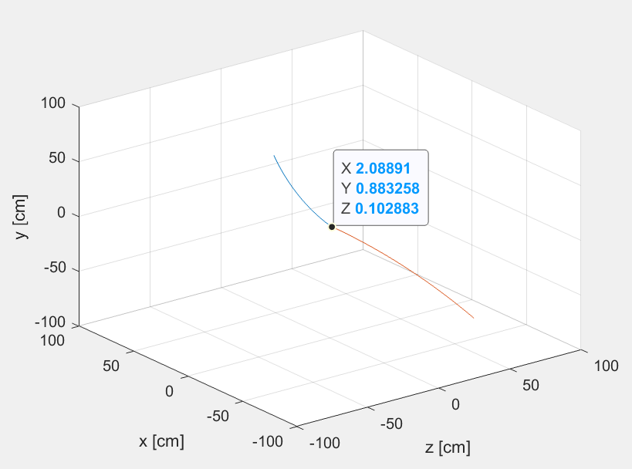
Note that what MATLAB calls X, Y and Z are what we are calling z, x and y respectively.

The Vertex class
Adding the new methods for the Helix class was pretty self-explanatory, I did have to introduce a time input for the momentum method, since it was changing over time:
% finds momentum of particle in x,y and z direction
function x = p3(obj, t)
h = obj.trk.curvature;
d0 = obj.trk.d0;
phi0 = obj.trk.phi0;
v = obj.points(t);
x(1) = abs(obj.pt) * ((1 + 2 * h * d0) * cos(phi0) - 2 * h * v(2));
x(2) = abs(obj.pt) * ((1 + 2 * h * d0) * sin(phi0) + 2 * h * v(1));
x(3) = abs(obj.pt) * obj.trk.cotTheta;
end

apart from this, the methods were simple.
I then created the Vertex class and added the methods to find the flight distance, impact parameter and lifetime of the particle which decayed to give two helices. This class took in an array of two Helix class variables and had three properties: one for each helix, and one for the vertex of intersection. To differentiate between the two vertices I had the constructor choose the vertex with the smallest difference between z values, so that it would find the more accurate result. My code is as follows:
classdef Vertex
% Vertex contains data about the point of a particles decay and the two
% daughter bodies:
% 'h1' is one of the resulting paths
% 'h2' is the other resulting path
% 'vtx' is the coordinate of decay

properties(Access=protected)
h1
h2 % initial helices
vtx % vertex of intersection (point of decay)
end

methods

% constructor
function obj = Vertex(h) % Input must be a 1x2 array of helices that form vertex
obj.h1 = h(1);
obj.h2 = h(2);
v = h(1).intersect(h(2));
if v(4:1) > v(4:2) % checking which intersection seems more accurate by finding the smaller difference in z values
obj.vtx(1) = v(1:2);
obj.vtx(2) = v(2:2);
obj.vtx(3) = v(3:2);
else
obj.vtx(1) = v(1:1);
obj.vtx(2) = v(2:1);
obj.vtx(3) = v(3:1);
end
end

function x = mass(obj, mass1, mass2)

end

function pT = pT(obj)
pT1 = obj.h1.pt*[cos(obj.h1.trk.phi0), sin(obj.h1.trk.phi0)];
pT2 = obj.h2.pt*[cos(obj.h2.trk.phi0), sin(obj.h2.trk.phi0)]; % initial transverse momenta
pT = pT1 + pT2; % conservation of momentum
end

function L_xy = FlightDistance(obj)
DF = CdfDataFile('cdf.dat');
event = DF.next;
DF.rewind;
wPV = event.vertex;
L_xy = dot(obj.vtx - wPV, obj.pT);
end

function d_0 = ImpactParameter(obj)
DF = CdfDataFile('cdf.dat');
event = DF.next;
DF.rewind;
wPV = event.vertex;
d_0 = cross(obj.vtx - wPV, obj.pT);
end

function ct = Lifetime(obj, mass1, mass2)
ct = (obj.FlightDistance * obj.mass(mass1, mass2)) / obj.ImpactParameter;
end

end % methods
end % classdef

I kept the mass method empty since I didn’t know how to calculate the mass of the decaying particle yet.

Polymorphism
“It is worth noting that the straightforward Loop class is not necessarily the most practical in its implementation: in most cases, one should try to hold files open only as long as they are needed, and the current Loop class keeps the data file open even while the user isn't running the analysis. (This could be a problem in multi-user systems where one user opening a file, even just to read it, effectively locks out other users.) Instead, one could check that the file exists in the constructor, but open and close it in run(). In this way, the file is opened only while it is in use. This is also an example of how the programmer can improve the implementation of a class without changing how the class is used, whether by users directly or by other programs. Why would this be an advantage?”
It doesn’t disrupt how other people use the class or what they are using it for, and streamlines performance, making it quicker for everyone, without bothering them.

The strange meson
Firstly, I added the mass method to the Vertex class, I found the mass using results from special relativity:
$M^{2}=E^{2}-p^{2}$,
where $E=\sqrt{m_{1}^{2}+p_{1}^{2}}+\sqrt{m_{2}^{2}+p_{2}^{2}}$, and $p=p_{1}+p_{2}$. These masses and momenta correspond to the two resulting particles. The code therefore had to have two extra inputs depending on the mass. My code was as follows:
% function uses SR to find mass of decaying particle (c = 1 of course)
function x = mass(obj, mass1, mass2)
p1 = obj.h1.p3(obj.vtx); % momenta of resulting particles
p2 = obj.h2.p3(obj.vtx);
E = sqrt(mass1^2 + norm(p1)^2) + sqrt(mass2^2 + norm(p2)^2); % finding the energy of the decaying particle INCLUDING NON TRANSVERSE MOMENTUM
x = sqrt(E^2 - norm(p1 + p2)^2); % using the energy momentum relation to find the mass of the decaying particle
end
I also had to alter some of my previous methods for the following analysis. I changed my p3() method to have an input of position instead of time. I also introduced an input for finding the primary interaction vertex of each event for my methods for flight distance and impact parameter in Vertex.
I started by analysis by filling in the properties for the K0Analysis class. The properties of objects of this class are the array of masses measured (massarray) and an object from the histogram class which contained these masses (mass). massarray was set to be protected and mass was set to be public so you could plot results but not alter them. I also set a constant property mp, the mass of the pion, since we were assuming that pions were the result of the kaon decay. The constructor set the massarray and mass to empty arrays.
The start() method involved setting up the mass to be of the Histogram class with 100 bins from 0.4 to 0.6 GeV/c^2 as stated in the lab script. The stop() method filled the mass property with all the masses in massarray so that it could be plotted. The event() method is the most complicated, I started by finding all helices, in an array and then making a new array with tracks that matched the criteria give, I then checked every possible combination of these helices for a certain event, making sure the radii had opposite sign (opposite charge) and setting extra constraints to remove background. The code for this class is as follows:

classdef K0SAnalysis < Analysis

properties (Constant)
mp = 0.13957
end
properties (Access=protected)
massarray
end
properties (Access = public)
mass
end

methods

% constructor
function obj = K0SAnalysis()
obj.massarray = []; % this will contain all the measured masses
obj.mass = []; % this will become a Histogram object that we can plot
end

% setting up the histogram
function start(obj)
obj.mass = Histogram(100, 0.4, 0.6); % 100 bins from 0.4 to 0.6 GeV/c^2
end

% filling the histogram up with the measured masses
function stop(obj)
obj.mass.fill(obj.massarray)
end

% executes every event to find measured masses
function event(obj, ev)
piv = ev.vertex'; % transposing the primary interaction vertex for convenience (from 2x1 to 1x2)
tracks = ev.tracks;
allhelices = Helix(tracks); % all helices for an event
helices = [];
for k = 1:numel(allhelices)
if all([abs(allhelices(k).pt) > 1, abs(allhelices(k).ip(piv)) > 0.3]) % finding helices which match our criteria
helices = [helices, allhelices(k)];
end
end
for i = 2:numel(helices)
h1 = helices(i);
r1 = h1.radius;
for j = 1:i-1 % for all possible combination of helices...
h2 = helices(j);
r2 = h2.radius;
v = Vertex([h1, h2]);
vertex_ij = v.vtx;
if isempty(vertex_ij) % if no intersection is found
continue
end
if all([sign(r1) ~= sign(r2), v.FlightDistance(piv) > 2, abs(v.ImpactParameter(piv)) < 0.5]) % more criteria for our chosen intersection
obj.massarray = [obj.massarray, v.mass(obj.mp, obj.mp)]; % assuming both tracks are pions, we find the predicted mass of the decaying particle
end
end % second loop of helices
end % first loop of helices
end % event()

end % methods
end % classdef

To test this, I used the Loop class to plot my results:
ka = K0SAnalysis;
loop = Loop('cdf.dat');
loop.run(ka)
ka.mass.plot();
xlabel('mass [GeV/c^2]');
ylabel('entries/(2 MeV/c^2)');

This gave me the following histogram:
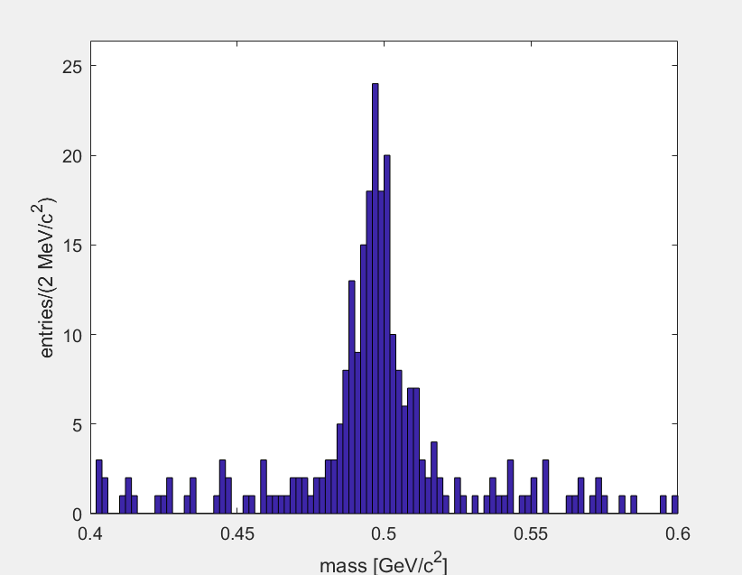
This had a peak of around 0.5 GeV/c^2 over a uniform background of random events, which matched what was expected ($m_{K_{S}^{0}}=0.4976$GeV/c^2).
The peak has width of around 4 MeV/c^2. This could be for a number of reasons. Firstly, kaons can decay through other modes as well with a lower probability, this can seemingly give the kaon a different measured mass, and result in a shift of the peak all together. There are also uncertainties in measuring these values with the detectors themselves.

The strange baryon
To analyse the mass of the lambda baryon I made the LambdaAnalysis class almost identical to the K0SAnalysis class, but I changed some of the conditional parameters as well as adding different cases, assigning different tracks the mass of the proton/pion depending on their transverse momenta:
if all([sign(r1) ~= sign(r2), v.FlightDistance(piv) > obj.minlxy]) % more criteria for our chosen intersection
if all([h1.pt > h2.pt, abs(h1.pt) > 2]) % finding whichever track has a higher pt and assigning it the mass of a proton (also must match criteria)
obj.massarray = [obj.massarray, v.mass(obj.mproton, obj.mpion)];
elseif (h1.pt < h2.pt) && abs(h2.pt) > 2
obj.massarray = [obj.massarray, v.mass(obj.mpion, obj.mproton)];
end
end

Applying this to the same test code and changing the range of the histogram to 1.0-1.2 GeV/c^2 I obtained this:
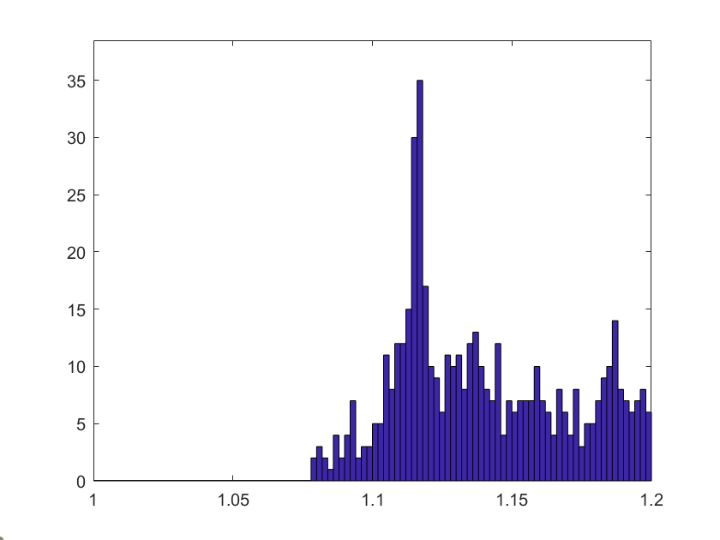
This graph was very noisy compared to the previous one, but it had a peak at the expected value. This meant that it was only a problem of removing background. (The graph has no values below around 1.07 since that would imply the lambda baryon had less mass than its decayed particles added which isn’t possible).
Retrying with different conditions:
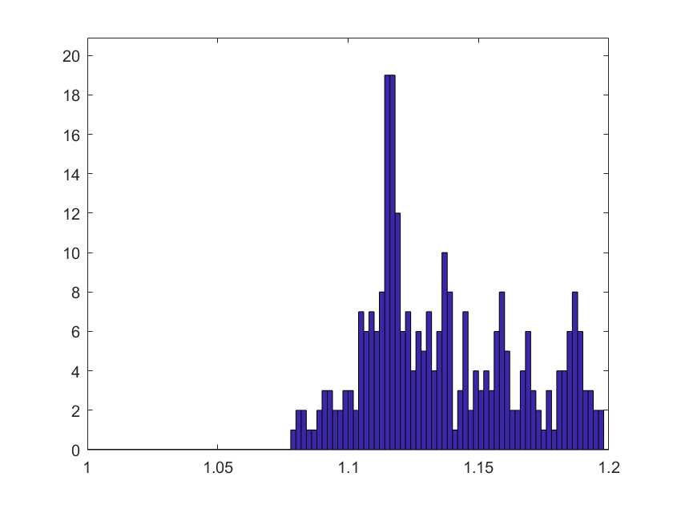
la.minlxy = 4;
la.mind0 = 0.4;
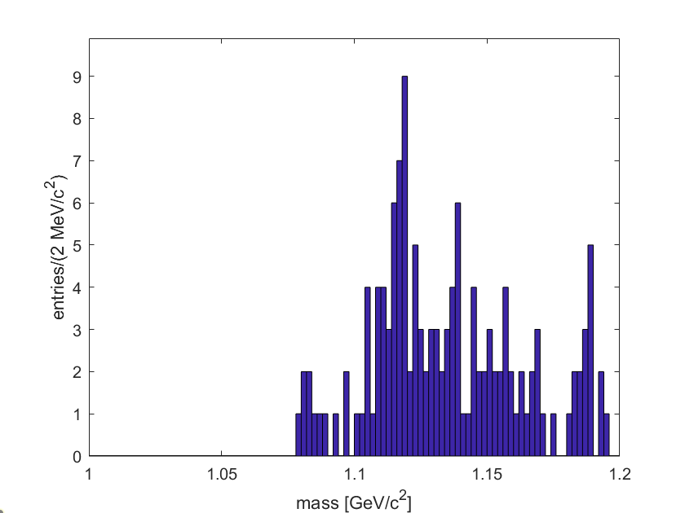
la.minlxy = 8;
la.mind0 = 0.8;
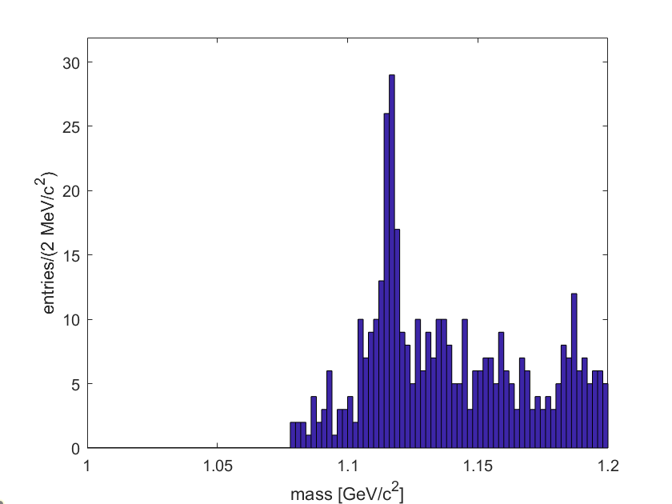
la.minlxy = 8;
la.mind0 = 0.2;
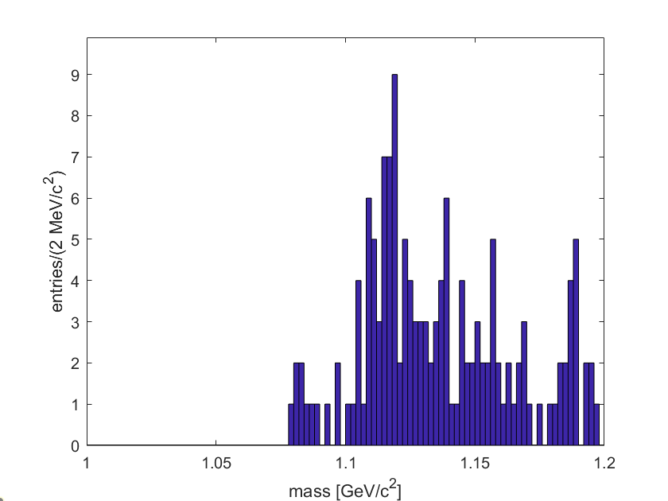
la.minlxy = 2;
la.mind0 = 0.8;
Setting the minimum flight distance and impact parameter to 2cm and 0.2cm respectively seemed to be the best for removing background, but it was still far from perfect compared to the kaon measurements.
Trying the same for the kaon measurements:
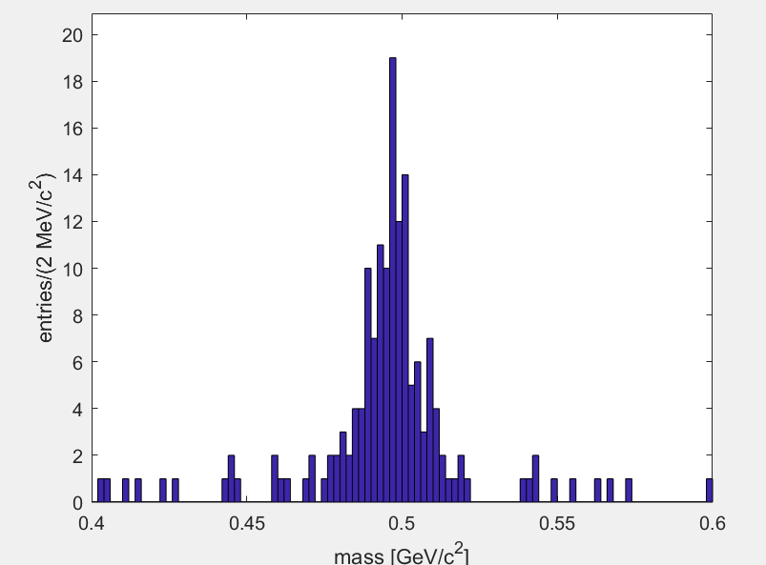
ka.minlxy = 4;
ka.mind0 = 0.6;
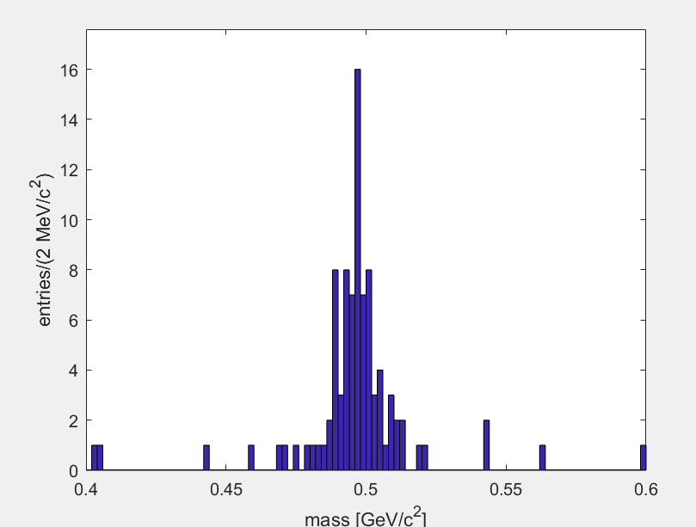
ka.minlxy = 8;
ka.mind0 = 1.2;
Setting the minimum flight distance and impact parameter to 8cm and 1.2cm respectively seemed to be the best for removing background, but this left too few results for the peak.

Fitting the strange meson lifetime
Using the K0SAnalysis class I added more properties so that I could analyse the lifetime of the kaon using vertices with predicted masses similar to that of the kaon. To remove background, I sampled masses around the peak and removed this from the sample of masses at the peak:
if all([sign(r1) ~= sign(r2), v.FlightDistance(piv) > obj.minlxy, abs(v.ImpactParameter(piv)) < 0.5]) % more criteria for our chosen intersection
obj.massarray = [obj.massarray, v.mass(obj.mp, obj.mp)]; % assuming both tracks are pions, we find the predicted mass and lifetime of the decaying particle
if v.mass(obj.mp, obj.mp) > 0.48 && v.mass(obj.mp, obj.mp) < 0.52
obj.ctarray = [obj.ctarray, v.Lifetime(obj.mk, piv)]; % vertices within the peak are added to lifetime array
elseif v.mass(obj.mp, obj.mp) > 0.46 && v.mass(obj.mp, obj.mp) < 0.48
obj.ctsidearray = [obj.ctsidearray, v.Lifetime(obj.mk, piv)]; % vertices just outside the peak are measured as background
elseif v.mass(obj.mp, obj.mp) < 0.54 && v.mass(obj.mp, obj.mp) > 0.52
obj.ctsidearray = [obj.ctsidearray, v.Lifetime(obj.mk, piv)];
end
end

kb = K0SAnalysis();
kb.minlxy = -999;
kb.mind0 = 0;
loop = Loop('cdf.dat');
loop.run(kb);
kb.ctside.plot

I plotted the histogram of background results for $0≤ct≤15cm$ with 100 bins and got this:
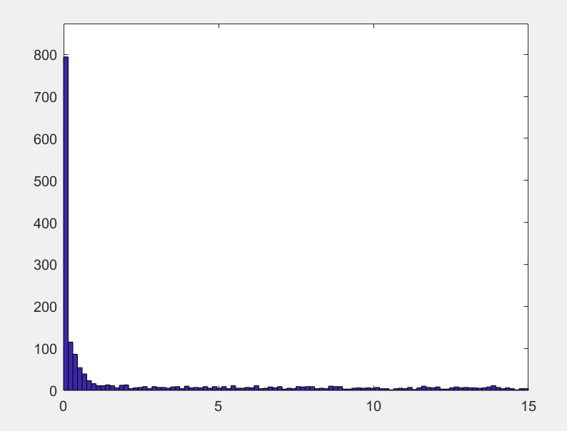
As you can see, there is a peak at 0 and some particles with a longer lifetime (explanation in lab script).
I then removed this background from my main sample to plot:
x = kb.ct.bins();
sig = kb.ct.data - kb.ctside.data;
err = sqrt(kb.ct.data + kb.ctside.data);
errorbar(x, sig, err);

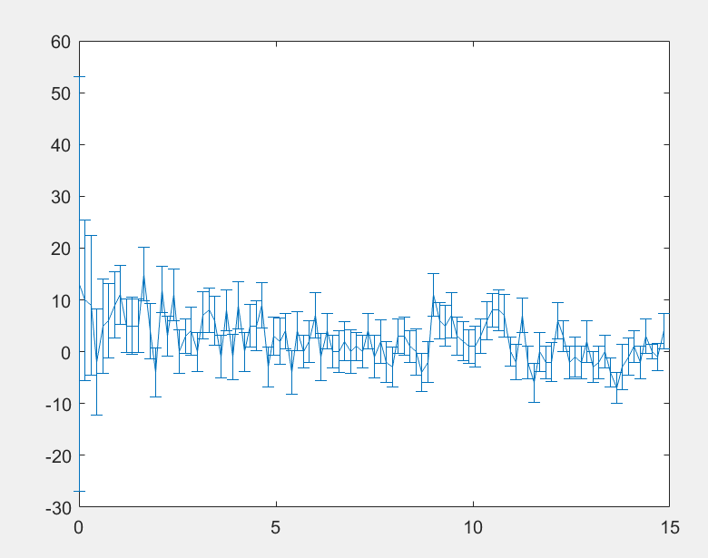
The graph seems to have the correct shape: it has a peak at $cτ=0$ and tends to 0 as it increases. However, the curve MATLAB drew was very jagged and the error bars did make visibility harder. I also plotted the same thing with the flight distance:
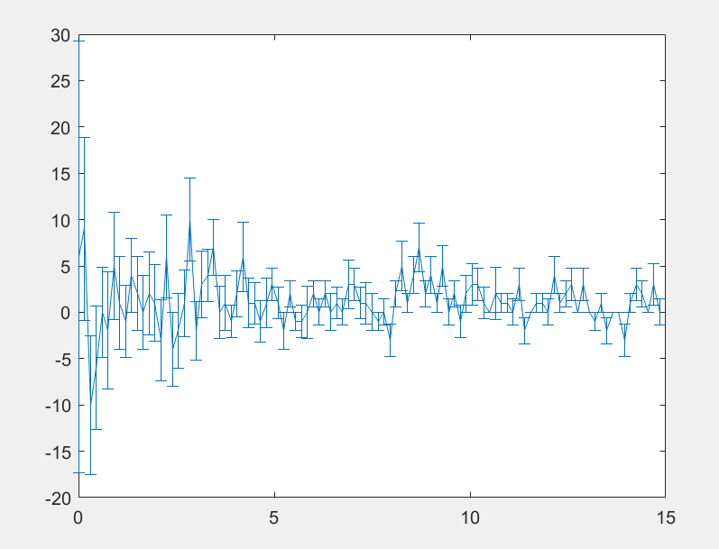
This graph had a peak at $L_{xy}=1.5cm$, which was around where we made our initial cut to measure the kaons mass. It fluctuates randomly above zero as we increase.
To measure the lifetime of the kaon I fitted the graph for ct with an exponential $y\left(t;A, τ\right)=\frac{A}{cτ}e^{-{ct}/{cτ}}$ for different values of A and c*tau. I chose values of A and c*tau around the expected values. To test how good the fit was I used a chi squared test and found the minimum value for the value of A and c*tau.
I plotted my results on a 3d graph:
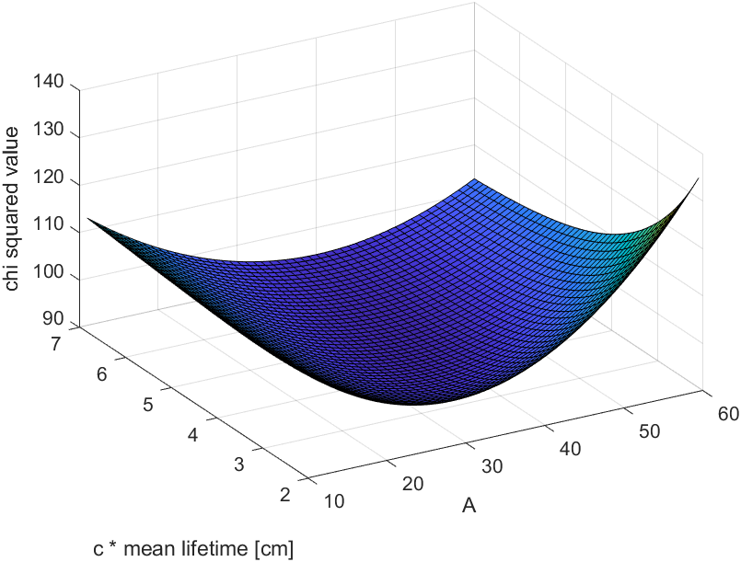
$χ^{2}$ had a minimum value of 92.315266786470630 for $cτ=4.5$cm and $A=36$. To find the uncertainty in c*tau I checked values for which the chi squared would increase by 1. This gave me $3.5≤cτ≤5.9$cm to 1 standard deviation.
This gave me the following final result for the mean lifetime:
$τ={1.5}_{-0.3}^{+0.5}×{10}^{-10}$s
The expected result was $τ=(8.954±0.004)×{10}^{-11}$s, which is two standard deviations away from my result. This error may be due to not removing enough background, which contains a number of long-lived vertices: kb.ct.overflow = 147, while kb.ctside.overflow = 131, meaning that there were 16 moments where ‘kaons’ lived over 3 times their lifetime, where there was a starting number of around 10. The reason it is so hard to full remove background is because there is barely any signal compared to the background when we do not make cuts to lxy or d0 and so this leaves less data to analyse properly.
I tried this method of analysis on the lambda baryon, and found this graph:
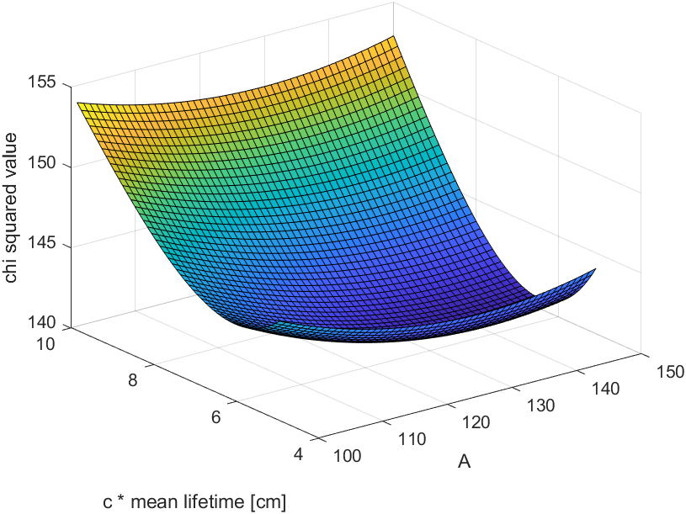
This had a minimum $χ^{2}$ value of around 140 for c * tau = 6.4cm. The final result was:
$τ=(2.1±0.2)×{10}^{-10}$s
The expected result was $τ=(2.631±0.020)×{10}^{-10}$s, which is two and a half standard deviations away from my result. This result was even further, due to the higher signal to background ratio, which also resulted in a higher minimum chi squared value. This result was lower than expected since the background removed was now all short lived particles.

